Name _______________________________, _________________________________

Challenge 3A
You need to program the robot to….
  - Use the ‘Color’ Sensor and the Touch LED only
  - After you start the program, the Touch LED should become the same colour as the object you put underneath the ‘Color’ Sensor.
  - When you put a different coloured object underneath, the Touch LED should show us the new colour.
- Teachers Signature ________________________________________________________
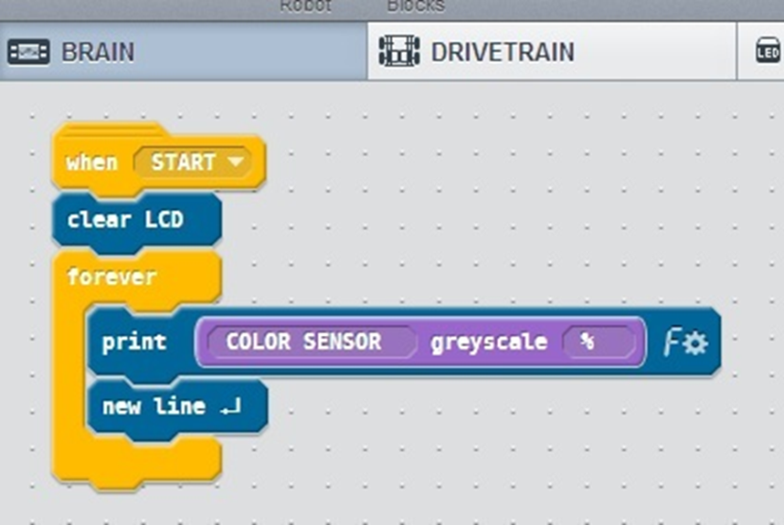
- Hint

Challenge 3B
You need to program the robot to….
  - At the start of our program the Touch LED to set to become white, the robot will wait for 1 second before doing anything else.
  - After this, the robot should drive forward when it sees black underneath the ‘color’ sensor (or close to black) and stop when it no longer sees black.
  - We will need to tell the robot what ‘black’ means using the data from our experiment.
  - The robot TOUCH LED light should be green while driving forward and red when stopping.
  - Teachers signature ________________________________________________________

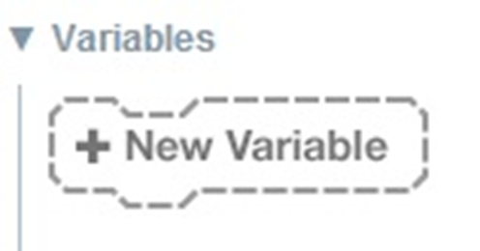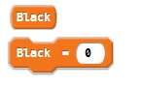
We will use a variable called ‘black’ to inform the robot of our experimental data.
You can create a variable by clicking on the ‘New Variable’ block at the very bottom of interface.
A variable name can be anything, but choose it sensibly (‘Black’ in our example). After entering it, 2 new blocks with that name will appear.
One block just has the name, the other also has a field to put in some data.
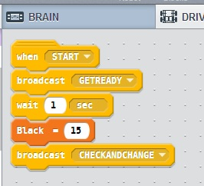
In the Brain section we will define our variable ‘Black’.
After the program is finished and has been tested, students should be invited to change this value and observe the changes in behaviour over different coloured pieces of paper.
The rest of our program uses commands and constructions the students have been introduced to before.
Students should try to complete the program on their own (possibly with some guidance).

