Group # _____
Color
WHAT YOU WILL NEED:
- GETTING STARTED:
Click on the 'Blocks' tab and make sure that you are editing the 'Brain'. Drag and drop code blocks to match the image below. The 'when START' block runs once each time your program runs. The 'forever' block repeatedly runs the code inside.
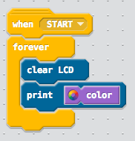
- Download your program, and run it on the physical VEX IQ brain. I have provided a graphic that you can use to test your program (see my WEB page);
  - Simply print out the color wheel (page 1). Point the color sensor at the color wheel and observe the color printed on the VEX IQ brain.
  - The default mode of the color sensor is '3-color'. The benefit of using this mode is that it easily distinguishes between the main colors red, green, and blue.
  - The limitation is that it does not recognize colors such as yellow, orange, and purple.
  - Teachers signature
_____________________________________________________________________
- Next, let's modify the program to perform different actions based on the color it detects.
  - Drag and drop code blocks to match the image below.
  - If the color sensor detects GREEN when the program is run, then the message "Ready to go!" will be printed. Otherwise, the message "Waiting for green signal..." will be printed.
  - Otherwise, the message "turn left to return" will be displayed.
  - Download your program and test it on your device.
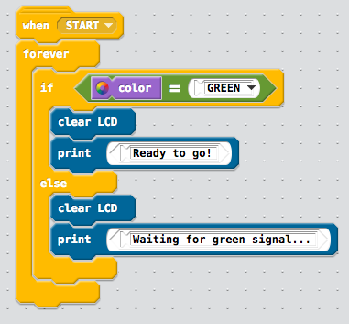
  - Download your program, and run it on the physical VEX IQ brain. We've provided a second graphic that you can use to test your program (see attachments below); simply print out the green go!
  - Teachers signature _______________________________________________________

