Design Problem #1

Design a key chain
- Must be 3 dimensional
- Must be a minimal of 3” long by 1.5” wide
- Must have multiple layers.
- Must have Multiple shapes
- Include either text or a graphic design.
- You must turn in a ACAD drawing along with a printed object
Grading will be reflected on the above criteria.
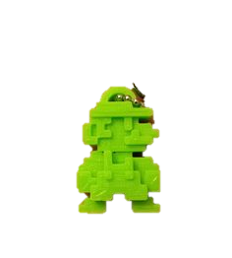
Deductions
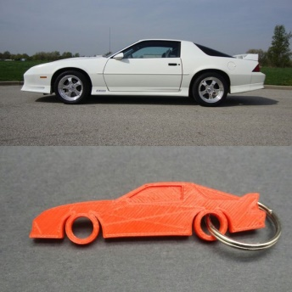
Dimensions 20pts
Layers 25
Shapes 25

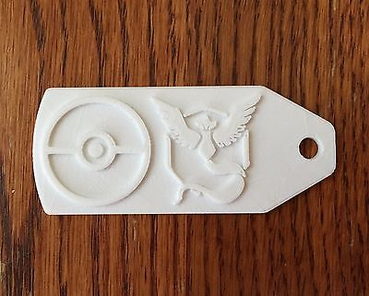
Graphic\text 30

