Group # _____
Distance
WHAT YOU WILL NEED:

- GETTING STARTED:
- Let's create a program that measures the distance to the closest detected object.
- Open the Modkit for VEX editor. Drag and drop a distance sensor and assign its port number. Make sure it
- Next, click on the 'Blocks' tab and make sure that you are editing the 'Brain'. Drag code blocks to match the image below.
  - The 'when START' block runs once each time your program runs.
  - The 'forever' block repeatedly runs the code inside, allowing your program to change and respond as it runs.
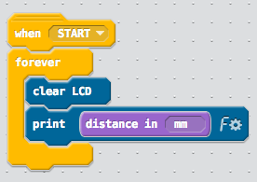
- Download your program and run it on the physical VEX IQ brain. I have provided a graphic that you can use to test your program (See my WEB page); simply print out the graphic, and assemble the barrier as instructed on the print out.
- You can make as many barriers as you'd like. Point the distance sensor at a barrier, and observe the distance value printed on the brain.
Teachers signature
  - _____________________________________________________________________

- Modify the program to detect objects within a set distance.
  - Drag and drop code blocks to match the image below.
  - Set the distance range to 100mm.
  - If an object is detected in the range, the message, "STOP! Object detected" will appear on the VEX IQ brain.
  - Otherwise, the message "All clear!" will be printed.
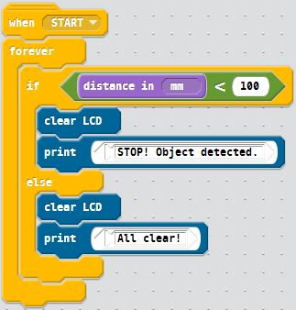

- Download your program and run it on the physical VEX IQ brain
- Use the sensor and printed scale to measure distance
  - Teachers signature _________________________________________________

