Drawing 8

2 point pivot

[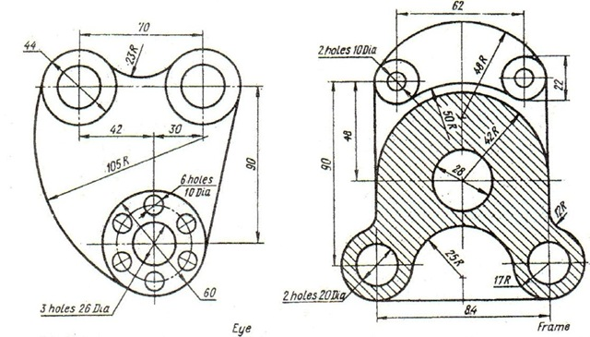](https://www.google.com/url?sa=i&rct=j&q=&esrc=s&source=images&cd=&cad=rja&uact=8&ved=0ahUKEwjN5tSQuo3SAhVI4CYKHWGyBuoQjRwIBw&url=https%3A%2F%2Fsseaimes.wordpress.com%2Fcategory%2Faimes%2Fautocad%2Fpage%2F2%2F&psig=AFQjCNG-eO0JySHX630iDWvfzol9YKjcgQ&ust=1487088387476681)