Group # _____
GYRO
WHAT YOU WILL NEED:
- GETTING STARTED:
Click on the 'Blocks' tab and make sure that you are editing the 'Brain'. Drag and drop code blocks to match the image below. The 'when START' block runs once each time your program runs. The 'forever' block repeatedly runs the code inside.
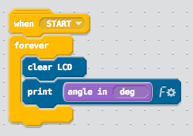
- Download your program and run it on your physical VEX IQ brain. I have provided a graphic (see attachments on my WEB page) that you can use in order to test the gyro; simply print it out and place your gyro on top of the coordinate system.
- While the program is running, rotate the gyro and see what values are printed on the screen of the VEX IQ brain.
  - The angle tells you how much you have rotated it from its original position.
  - Note: the 'original position' of the gyro is set each time you run the program on the brain. How does the angle change as you rotate the gyro?
- Teachers signature
  - _____________________________________________________________________
- Next, let's modify the program to perform a different action based on the measured angle.
- Drag and drop code blocks to match the image below.
- If the angle of the gyro is between 0 and 180 degrees, the message "turn right to return" will be printed on the VEX IQ brain.
- Otherwise, the message "turn left to return" will be displayed. Download your program and test it on your device.
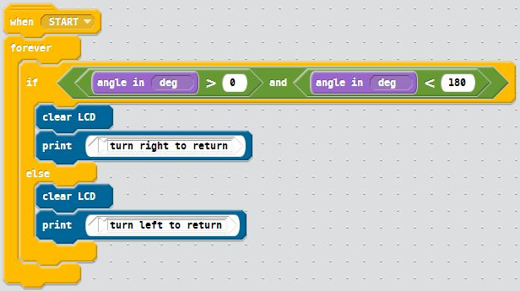
- While the program is running, rotate the gyro, and follow the messages printed out on the brain. Can you rotate the gyro back to its original position?​
  - Teachers signature _______________________________________________________

