Individual project. (NO GROUPS)
Name ________________________________
WEB PAGE DESIGN SHEET
Name of web page _________________________________________
Name of company _________________________________________
Type of business ___________________________________________
Products being sold _________________________________________
Individual project. (NO GROUPS)
You cannot use a template. All pages are created from scratch
Web page must include:

- Layout sketch
- Navigation bar
- Minimal of 5 pictures
- Minimal 1 video
- Minimal of 3 pages (accessed through the navigation bar)
- Text header
- Anchor links
- Social media links
- External links
- Follow copyright guidelines
- Correct grammar
- Good overall organization
  - Design
  - Appearance
- Begin with the information that you provided above.
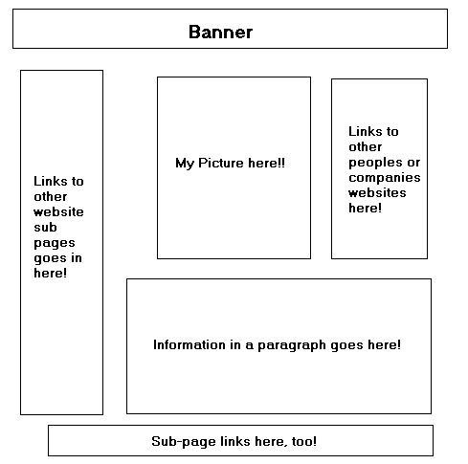
- Create a sketch of how you think the pages will lay out. Separate sheets of paper
- Refer to the sample

